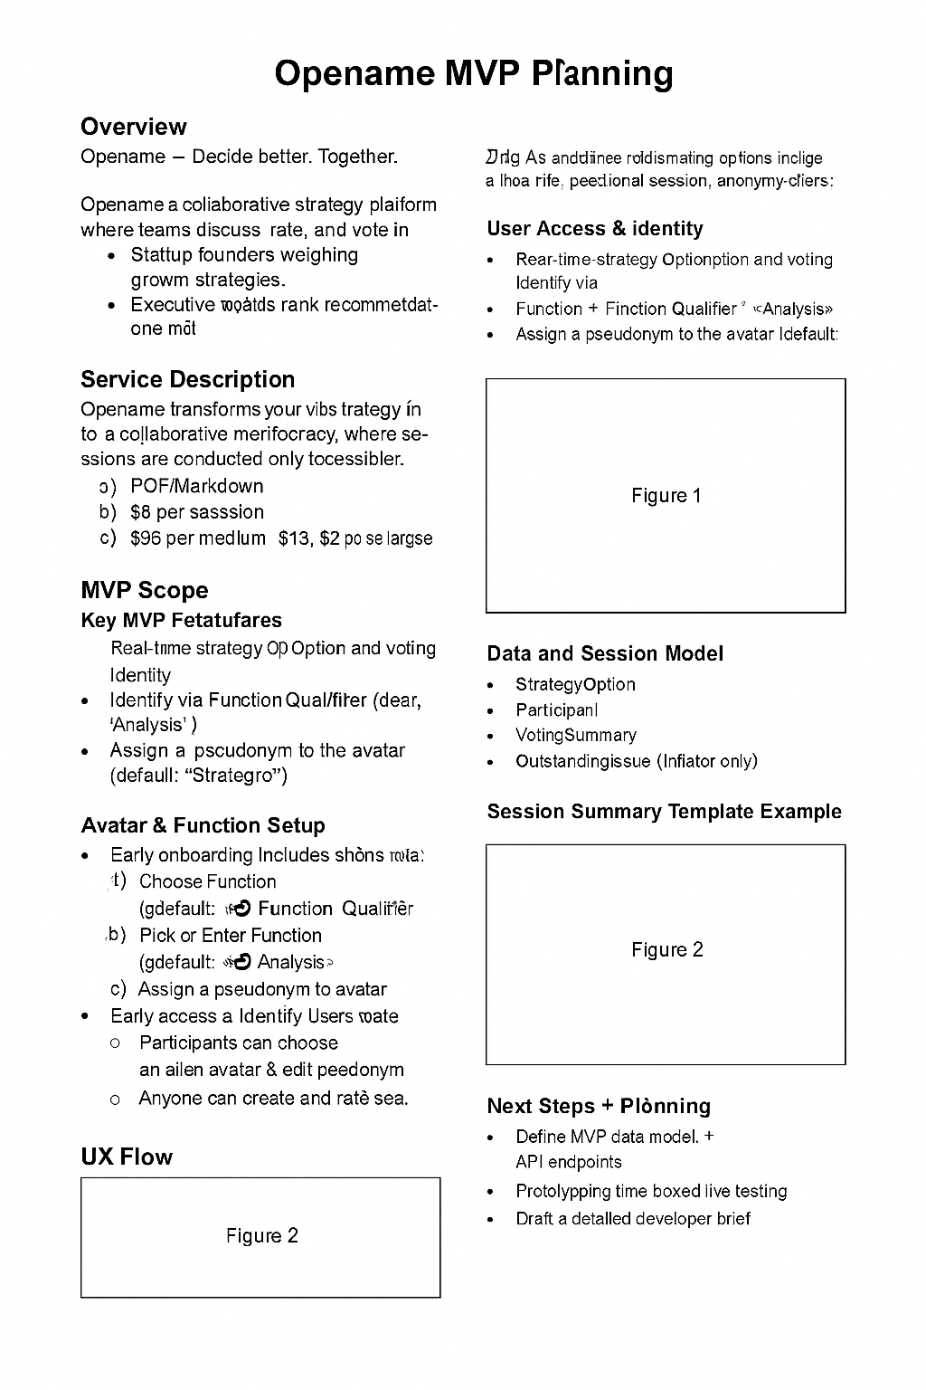
Opename MVP Plan

Overview

Opename is a team collaboration platform for evolving and concurrently evaluating a question's answer options, in real time. Participants respond to the session-initiator's session question via multiple answer/strategy options which are also created and edited by all participants, in real time.
Thus, participants vote for answer options, while discuss them via video-conference, and while participants refine the session's option name/description pairs. Only the registered initiator can define and refine the session question, because this can easily throw-off past voting.
All session participants must be pre-gated by the session-initiator, and all participants use a pseudonym/avatar to which Function tags and participant endorsements attach.
The platform will be marketed to founders, product teams, executive boards, advisory councils and organizations that prefer meritocratic decision-making.

Service Description

The system supports:
- Named answer/strategy options tied to a session question
- Peer trophy-voting for answer/strategy propositions
- Peer star-endorsement of other participant's Function + Qualifier
- Anonymous access to landing page, which shows an example session in progress, and a sample Session Summary, without visitor needing to login
- Registered access to session creation page, including Question creation/editing.
- Anonymous access to combined Question and Answer Options page, including session discussions and current vote/endorsement statistics, (access dependent on session-initiator consent)
- White-label (no logo), downloadable summaries for sharing by session-initiator
- No permanent data retention unless explicitly saved during registration or session-end processes

Lifecycle:

- Initiator creates question and starts session
- Users join, create/edit answer options
- Voting, discussion, and endorsements happen in real time
- Initiator exports session summary, when ending session
- Data is deleted, unless export saved by session-initiator

MVP Scope & Core Features

The MVP supports:
- Lifecycle, see above
- Question creation (initiators only)
- Answer/Strategy editing (all users)
- Voting weighted by Function endorsements
- Live editing and re-voting
- White-labelled session summary export

Data and Session Model

Core data entities:
- Question - editable by session-initiator only
- Options - Answer/Strategy Options, editable by all users
- Avatar – Identity placeholder for voters, incl, Function, Qualifier and avatar pseudonym
- Voter – registered or anonymous pseudonym, session-initiator approved for participation
- Vote_Option – a 1-5 level vote (trophy icons), voters assign to Answer Option(s)
- Endorse_Function – a 1-5 level endorsement (star icons), voters assign to other voter(s)

Session Summary Example

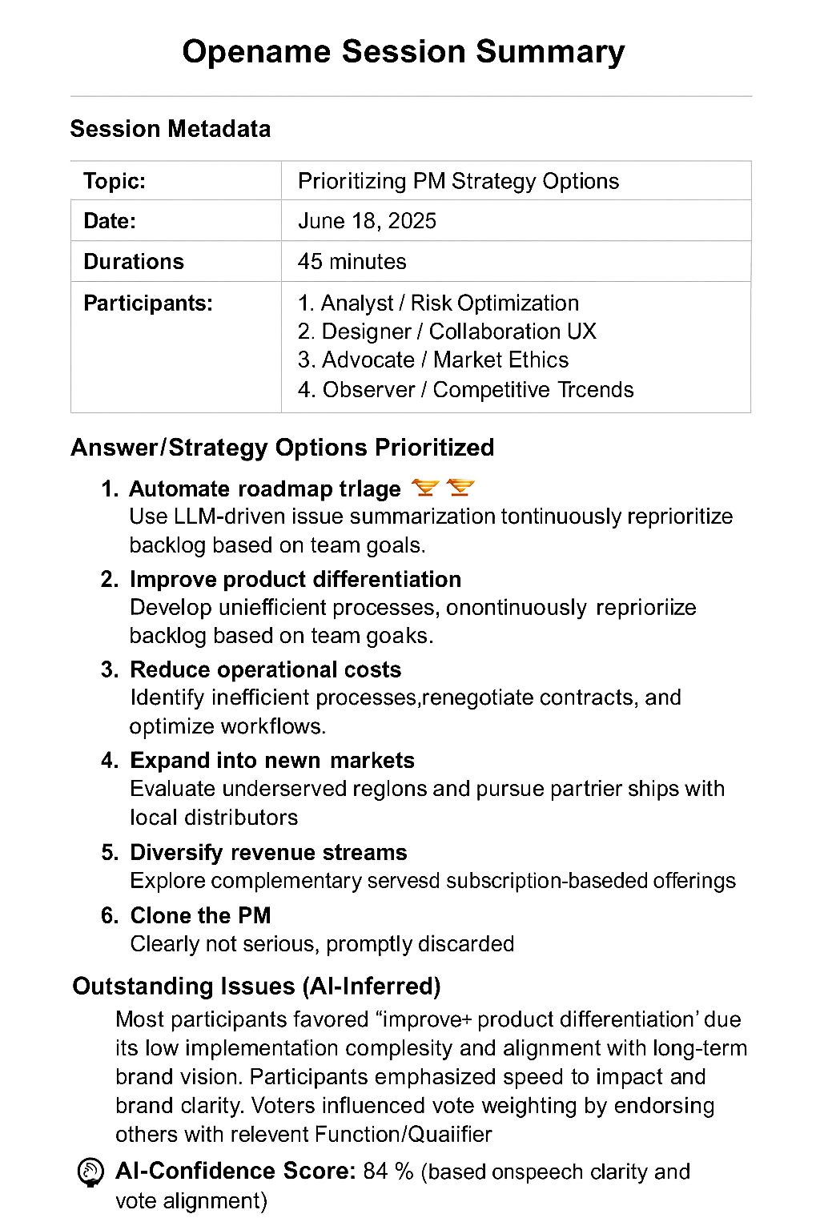

Next Steps for Implementation

- Confirm final MVP UX
- Produce each screen as a placeholder mockup
- Define database schema
- Draft OpenAPI-compatible spec
- Schedule prototyping and early testing

